*JavaScript Notes*

Storage in browser:
-to keep of the data transfer from server and client response the storage used those are : local storage, session storage and cookies.
Cookies: stored the session related information
cookies can be read by client and server
Cookies are used to store small amounts of data and are often sent with HTTP requests to the server.
-way to send the data to server

local storage:
-Everything in java-script happens inside a execution context like big box , container.
-read by only client
-no data flow to server

Session storage: Session storage is similar to local storage but is scoped to a single browser tab or window.
-only read by client
-no data flow to server

*execution context consist of two component :

1.memory allocation (variable environment) :all variables and function are stored in key value pair.
key: value //undefined
fn :{.....} //pointing to same exact function code

2.code component(Thread of execution): code executed line by line /one line at a time.

*Javascript is synchronous single threaded language.: only executed one command at a time in specific manner.

*How javascript code is executed: Global Execution context and Function execution context
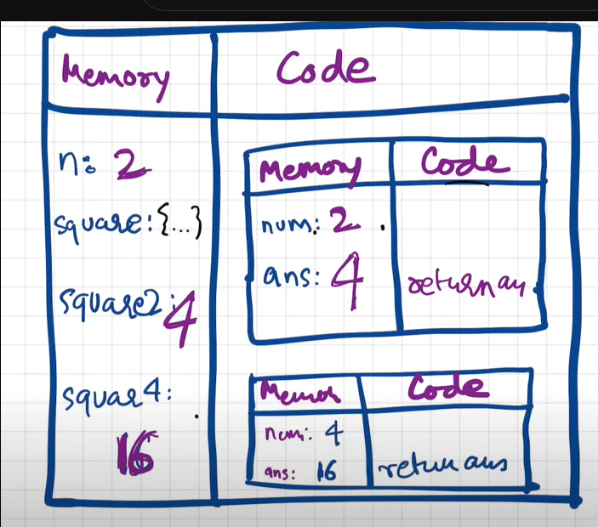
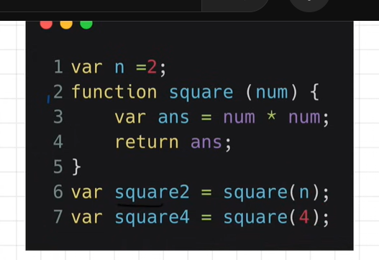

1.memory allocation phase:

In this phase java-script scan whole programme whenever variable found it allocate memory for that variable and assign value as undefined /special value to variable and for function whole block of code store inside memory in global execution context at a time of calling the function.

2.Code execution phase:

-After memory allocation, now actual value of variable assign to variable in global execution context.

-for function execution ,new brand code execution context created inside code execution having two phases like memory creation and code execution

-then consider function code , allocate memory to variable like actual variable and parameterized value. assign value to variable as undefined.

-return value then assign to global execution context variable like for square2 and square4.

-In code execution we ,execute each line

var n=2
function square(num){
var ans=num*num;
return ans;
}

var square2=square(n);
var square4=square(4);

-then argument passed to parameter perform operation in code execution block.

-perform function execution in inside execution context whenever we get return keyword we return that value and pass to variable. after function execution ,execution context will be deleted.
-after the execution of whole programme ,global execution context deleted.

*Call stack: Execution Context get into the Global Execution Context. // call stack is empty at last.

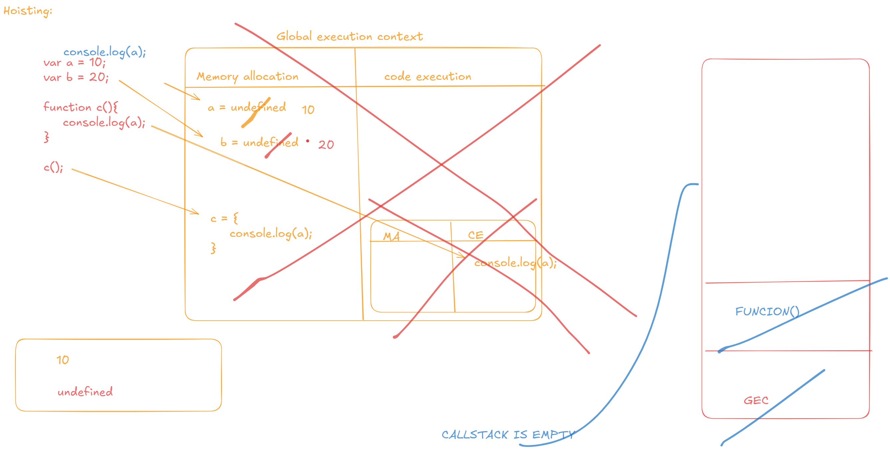

-The call stack is a crucial concept in JavaScript’s runtime environment, representing the mechanism by which the JavaScript engine keeps track of function calls in a program. It operates as a Last In, First Out (LIFO) data structure, meaning that the last function called is the first one to be resolved.

It is a stack, at the bottom global execution context will be their

-when function invoke ,new execution context (e1) created ,that put into stack. after execution e1 ,pop out from stack and new function execution context(e2) put in stack and after execution e2 also pop out from stack and control goes to global execution stack.

-after execution of programme call stack get empty.
-call stack maintains the order of execution of execution context.

*call stack also known as execution context stack, program stack, control stack, runtime stack, machine stack

*Hoisting in JavaScript:
*Hoisting is nothing but we can access variable and function in javascript even before the initialization without any error.
-before initialization of variable and function if we want to access that then we get function content and variable value as undefined.
-like variable x is declare in program you can access it from anywhere.
-if we only log the getname not invoke it then it disply function in console

for variable : we get undefined
for function: we get function

-If we write function as a arrow function it defined just like a variable and assign undefined value.

//arrow Function:
var getName=()=>{
}
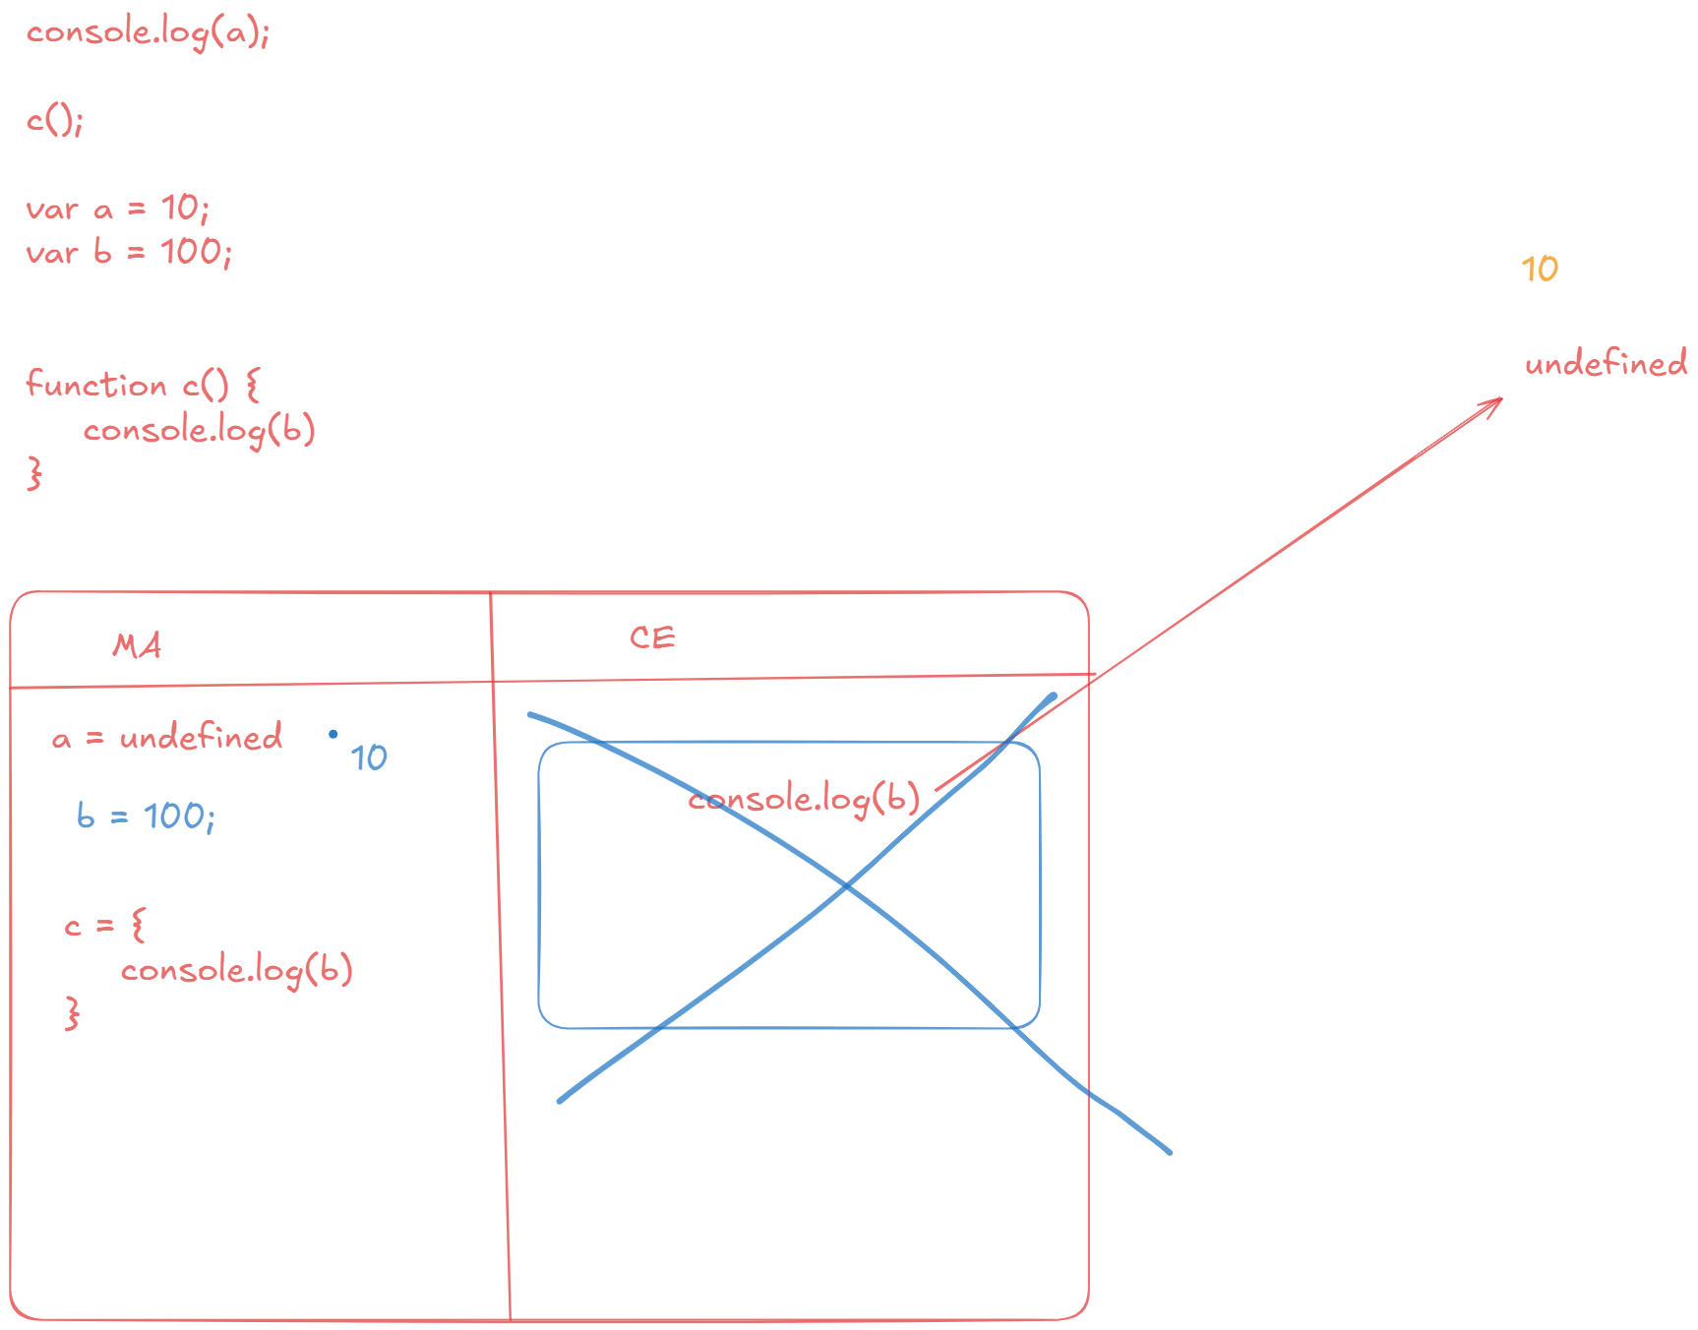

*Function In Javascript:
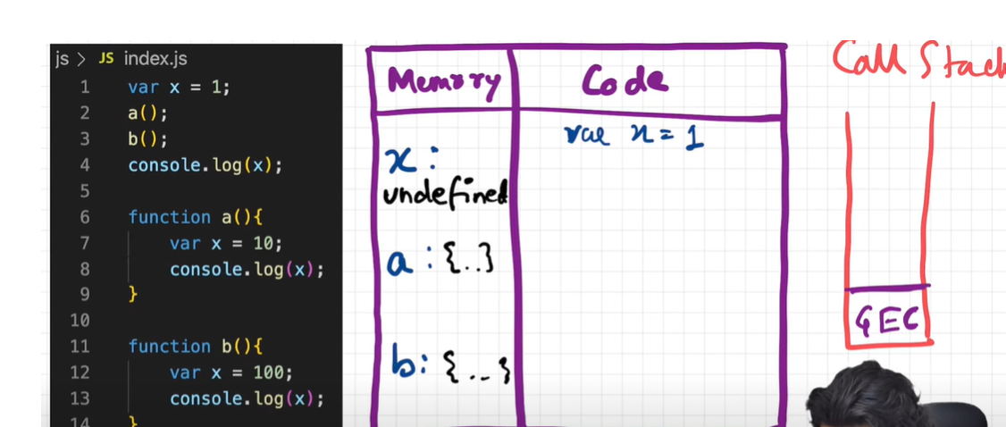
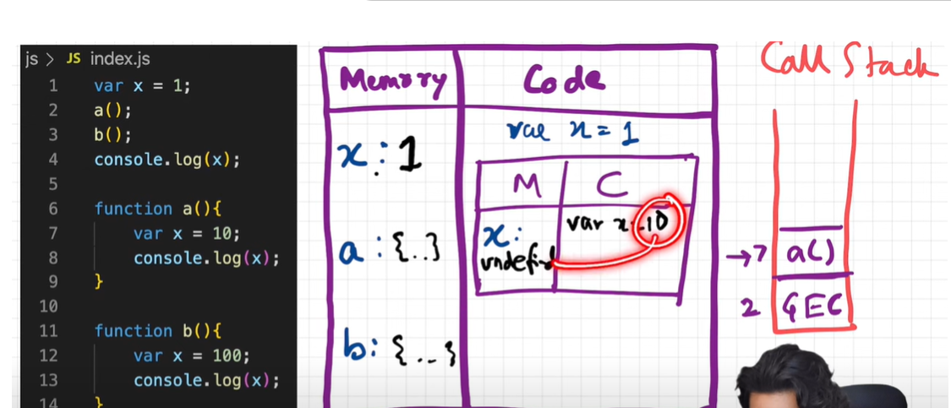
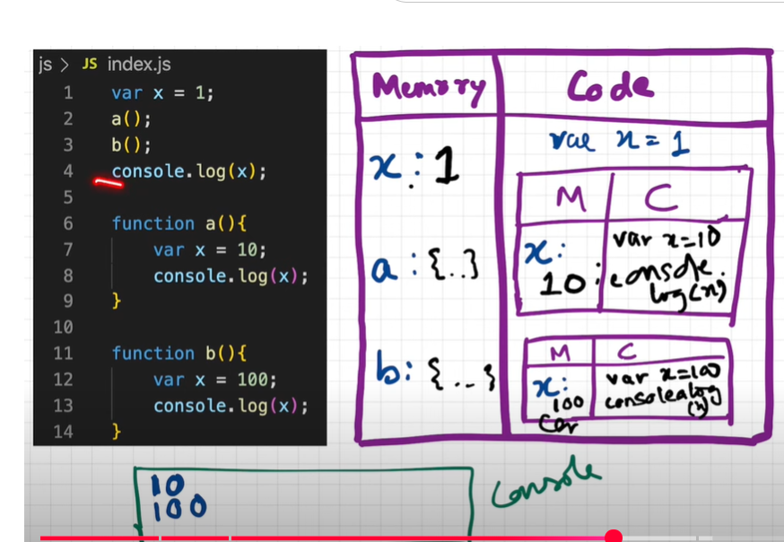

*Shortest Javascript Program:/ Empty javascript program:

-Whenever any javascript code executed along with global execution context this keyword and window global object created.
-this keyword is created at everytime during execution context but at global level this[keyword] ===window[global object]
*Anything not inside any function is on global space , so variable attach to global object
- The shortest JS Program is an empty program. When we run an empty Javascript code , a global execution context is created.

- In addition to that JS engine do something interesting, It also create window object. In addition to that JS Engine will also create this variable. At the global level this points to window object .

*Differance between undefined and not defined: [** Js is loosely type /Weakly type language **]

Undefined: In JavaScript, undefined is a predefined global variable that represents the value assigned to a variable during the compilation phase if no other value has been assigned to it.

Not Defined: not defined in JavaScript means that the variable hasn't been declared at all.

*The Scope Chain:
Scope is depend upon lexical environment.
Lexical-in hirarchy, in sequence, in oder (like c() is lexically inside a()) -->(created when execution environment created)

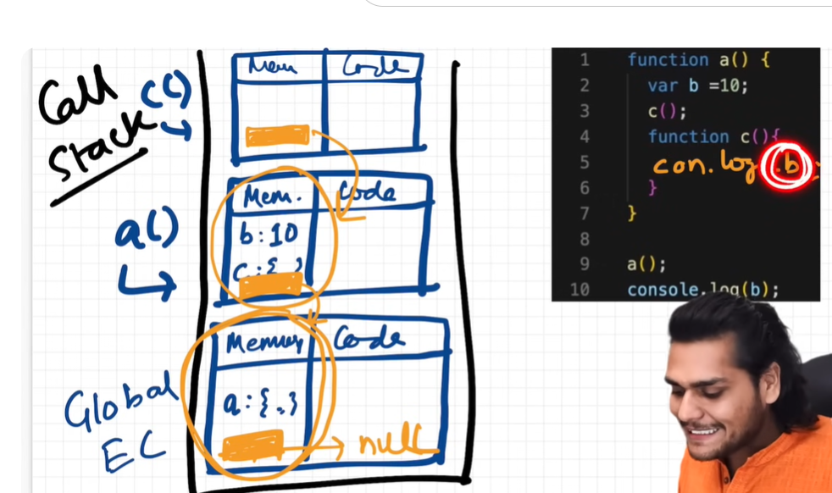

-lexical environment of C is lexical environment of A

-lexical environment of A is lexical environment of Global Execution context

-lexical environment of GEC is null

Scope chain:
Way of finding scope is called scope chain.
The scope chain in JavaScript is the mechanism that JavaScript uses to resolve variable references. When JavaScript encounters a variable name, it searches for the variable in the current scope. If the variable is not found in the current scope, the JavaScript interpreter searches the outer scope, and so on.

*Let And Const In JS: [let ,Const: reinitialize not possible]
for let first declaration then assignment possible but for const we needs to decalre and assign variable at a same time.
Let value will changable but const are not.
Let and cost declarations are hoisted.

Temporal Dead Zone:
- It is a specific region within a scope where variables exist but cannot be accessed until they are assigned a value. This zone starts at the beginning of the scope and continues until the point of declaration.
- let and const allocate different memory than the global space so we can access that variable only when we assign value to it.

Type error: if we pass another value to const variable
Syntax error: if we not assign any value to const variable, redeclaration let and const
referance error: when js engine try to found variable in temporal dead zone
not defined error: when we not declare variable

*Block Scoped and shadowing in JS?
Block: combine multiple js statement together so we used that when js expect single variable {.....}
Block Scope: only within block we access the let and const variable

Shadowing: same variable present outside the block
illegal shadowing : shadowing the same variable of different type.(let using var not possible but var using let possible)
let a=20;
{
var a=30;
}

Variable Shadowing in JavaScript occurs when the inner variable hides or overrides the outer variable within the local scope. In this situation, the outer variable cannot be accessed within the inner scope, only the inner variable is used in that scope.
- Variable Shadowing occurs when we declare the same name for the variable in the inner and outer scope.
- The inner variable will hide or override the outer variable.
- The outer variable will become inaccessible until the code exists in the inner scope.

let n = 5; // Outer variable
function a() {
let n = 10; // Inner variable that shadows the outer one
console.log(n); // 10 (inner n is used here)
}
a();
console.log(n); // 5 (outer n is still used here)

*Closure In JS: closure is a function bind together with its lexical scope. //function passed as a parameter.. //function along with lexical scope from closure.
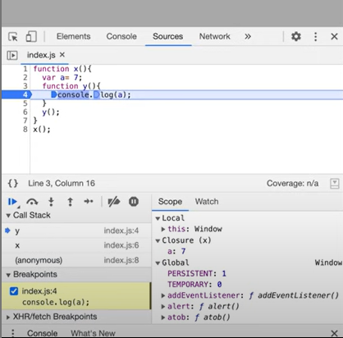
function x(){
var a=7;
function y(){
console.log(a);
}
y();
}
x();

A closure is a function that has access to its own scope, the outer function’s variables /parent function variables , and global variables, even after the outer function has finished executing.

- Global variables can be made private within a function using closures, ensuring they cannot be accessed or modified directly from outside.
- Closures are based on lexical scoping, meaning that a function’s scope is determined by where the function is defined, not where it is executed. This allows inner functions to access variables from their outer function.
- function outer() {
const outerVar = 'I am from outer';

function inner() {
console.log(outerVar);
}

return inner;}

const newClosure = outer();
newClosure();
- In the example above, inner() has access to outerVar because inner was defined inside outer, giving it access to the outer function’s scope.
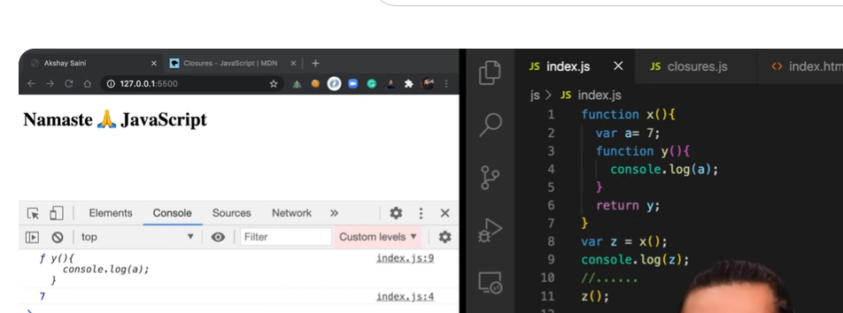
In this code, after exceution of x and y function ,exceution context has been deleted but if we call z() that stored the referance a .then y function search value of a in it’s lexical scope or within closure of y i.e., x() so return a=7. /

-function x access lexical scope of y and z also
fun z(){
fun y(){
fun x(){
}
}

}
z()()(); first z ()call the result of z store in y() and result of y store in x().

*uses of closures:
-module design pattern
-currying
-functionoing like once
-memoize
-maintaining state in async world
-setTimeouts
-Iterators and many more

*to print 1 to 5 by within timeinterval of 1s 2s 3s 4s 5s :

function x(){
var i=1;
setTimeout(function(){ //froms a closure and take value of i ,not wait for anything
console.log(i); //but due to var it print 6 everytime so we use let keyword.
},3000);
console.log(‘namaste’);
}
x();

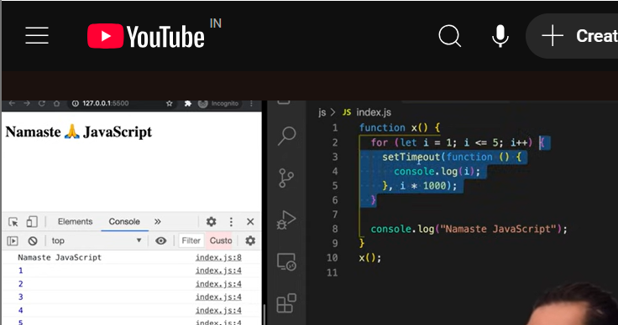
using var keyword (using closure).
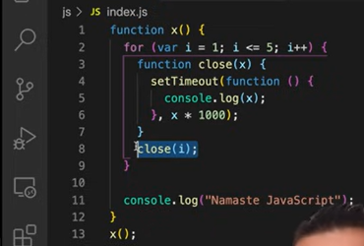

*Disadvantages of closure: overconsumption of memory , closued variable are not garbage collected
-closure occupied large memory

*First Class Function:/First class citizens: A programming language is said to have First-class functions if functions in that language are treated like other variables. A ability of function to use as a value and assign it to variable and can be passed it to function and can be return out of the function called first class function.

Usage of First-Class Function:
- It can be stored as a value in a variable.
- It can be returned by another function.
- It can be passed into another function as an Argument.
- It can also stored in an array, queue, or stack.
- Also, It can have its own methods and property.

1.Function Statement or function declaration: function statement during hoisting can occupy memory.
Function a(){
console.log(“ a statement”);}

2.Function Expression: A function expression is a way to define a function as part of an expression making it versatile for assigning to variables, passing as arguments, or invoking immediately.
-Function expressions can be named or anonymous.
-They are not hoisted, meaning they are accessible only after their definition ,if hoisted throws error like not a function.
Var b=Function (){
console.log(“ a statement”);} //anonymous function to create function expression

3.Anonymous Function: Function without name is called anonymous function.
-function that does not have their own identity
function (){
}
- It is used as a value

4.Named function expression: at a time of assign the function as a variable , we use function name for recursion and debugging .
var b=function xyz(){
console.log(“a statement”)}

5.Differance between parameter and argument?
-Function label and identifier which get those values (argument)are known as parameter.
-values are passed inside a function are argument.

*Callback Function In JS:
A callback function is a function that is passed as an argument to another function and executed later. In JavaScript, callbacks are functions that are passed as arguments from one function to another and are executed after the completion of a certain task.
- A function can accept another function as a parameter.
- Callbacks allow one function to call another at a later time.
- A callback function can execute after another function has finished.
setTimeout(function () {
console.log("Inside setTimeout");
}, 2000);
- setTimeout() is an asynchronous function that takes a callback to execute after 2 seconds.
- The rest of the code continues executing without waiting.
Used in: Api Request(fetching data), Reading files,event listener,database queries.
*Blocking Main Thread: This means that long-running JavaScript functions can block the thread, leading to an unresponsive page and a bad user experience.

Event Listener:
javaScript’s event listener function allows you to create custom responses to events like mouse clicks, keyboard clicks, and window resizing
button.addEventListener("click", RespondMouseClick, true);

Event listeners remain active until you remove them from the associated JavaScript elements. You can use the following syntax to do so.
button.removeEventListener("click", RespondMouseClick, false);
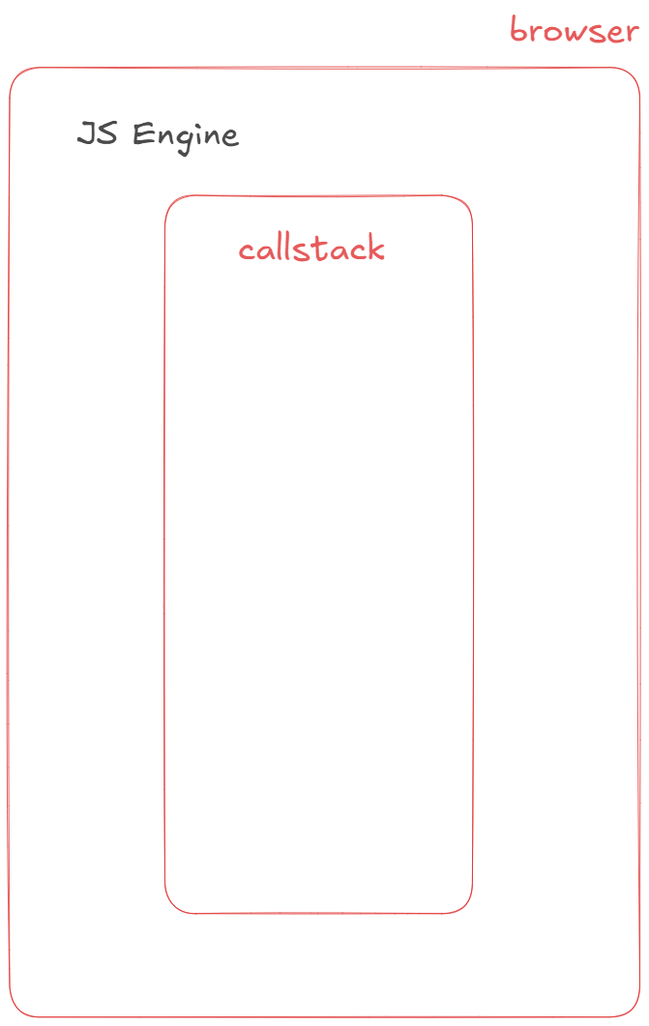
*Event Loop:
-call stack: For execution instantly .
*Web API: Parts of browser. Using global object(window) we use web API.
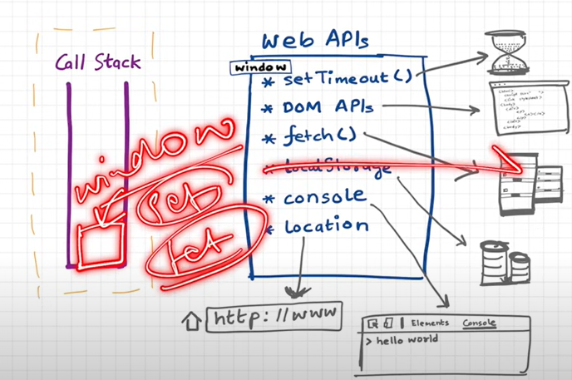
-setTimeout()
-DOM API’s(html structure dom tree)
-fetch()
-local storage
-console
-Location

*setTimeout: register callback. After the delay time complete then event loop and callback queue comes.
*Event loop: It is acts like a get keeper, when the callback function time get expired then call back function goes in callback queue after that event loop check whether any function present in call back queue ,it present then move that function to call stack for execution.
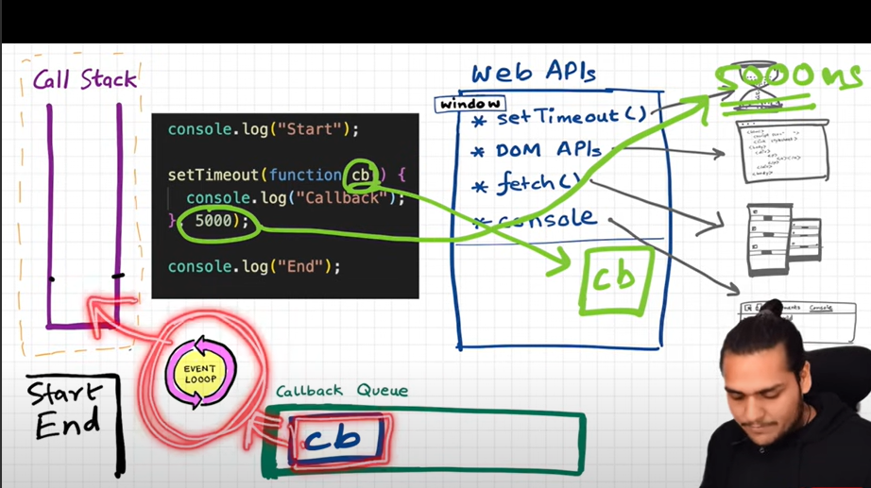

*V8(javascript engine for chrome)
-first javascript engine: spider monkey
*callback queue(task queue):It's job is to maintain a list of all of the callback functions that needs to be executed.

*Micro task queue: executed after the callstack is empty. for fetch web api , Has higher priority than callback queue.
-promises and mutations observer goes into microtask queue

*StarVation: If micro task queue executed continuously because of that a callback queue won’t get an opportunity to execute its tasks. This is called Start Vation.
*JS Engine: google’s V8 Architecture:
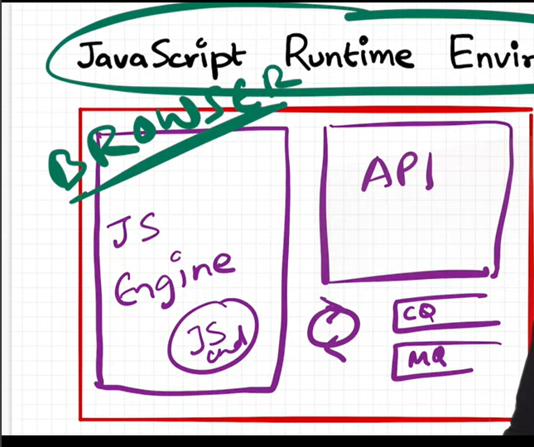
-JS Runtime Environment:

(js engine):(browser)
chakra: microsoft edge
spider monkey: mozilla firefox (first JS engine)
v8: chrome
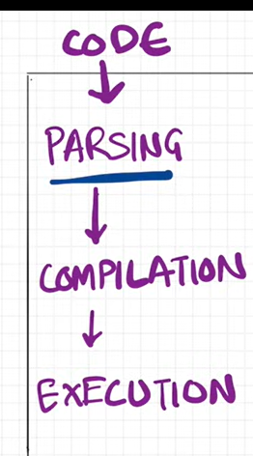
*JS engine is not a machine. It is just like normal
programme.

Parsing: code broken down into tokens let a =7 also called as syntax parser generate AST(Abstarct syntax tree)
compilation: JIT compilation used both interpreter and compiler
execution: memory heap(all functions and variable assign memory) and call stack
mark and sweep algorithm, inlining, copy ehision ,inline caching.
V8 Javascript engine architecture:
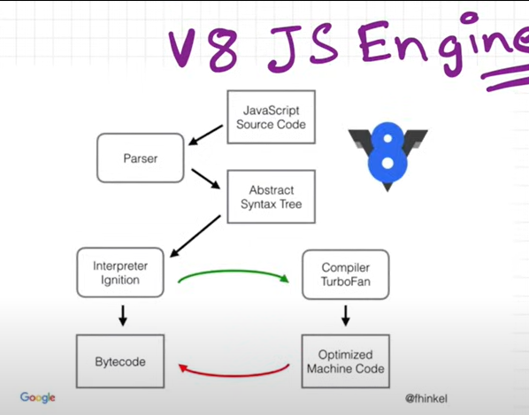

*orinoco( garbage collector):
concurrency model:
Trust issues with setTimeout():
-setTimeout with timer of 5 secs sometimes does not exactly guarantees that the callback function will execute exactly after 5s.
console.log('Start');
setTimeout(function cb() {
console.log('Callback');
}, 5000);
console.log('End');
// Millions of lines of code to execute
***First GEC is created and pushed in callstack.
- Start is printed in console
- When setTimeout is seen, callback function is registered into webapi's env. And timer is attached to it and started. callback waits for its turn to be execeuted once timer expires. But JS waits for none. Goes to next line.
- End is printed in console.
- After "End", we have 1 million lines of code that takes 10 sec(say) to finish execution. So GEC won't pop out of stack. It runs all the code for 10 sec.
- But in the background, the timer runs for 5s. While callstack runs the 1M line of code, this timer has already expired and callback fun has been pushed to Callback queue and waiting to pushed to callstack to get executed.
- Event loop keeps checking if callstack is empty or not. But here GEC is still in stack so cb can't be popped from callback Queue and pushed to CallStack. Though setTimeout is only for 5s, it waits for 10s until callstack is empty before it can execute (When GEC popped after 10sec, callstack() is pushed into call stack and immediately executed (Whatever is pushed to callstack is executed instantly).
- This is called as the Concurrency model of JS. This is the logic behind setTimeout's trust issues.

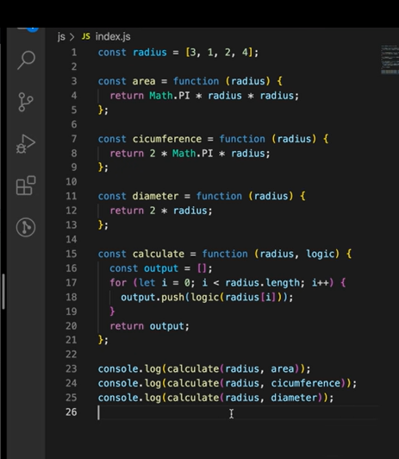
*Higher Order Function:
const radius=[3,1,2,4];

-calculate function is higher order function because we are passing a callback function as a parameter to it. and area, circumference and diameter are callback function.
-a function that takes other functions as arguments or returns a function as a result
-There are several different types of higher order functions like map and reduce.

*Map,Filter And Reduce: All are higher order function in JS.
*Map(): used to transform the array .The map() function takes an array of values and applies a transformation to each value in the array.
Arr=[5,2,3,1]
double=[10,4,6,2]

const arr = [5, 1, 2, 3, 6];
function double(x) {
return x * 2;
}
const output = arr.map(double);
console.log(output);

const output1 = arr.map((x) => 2 * x);
console.log(output1);

*Filter(): used to filter the array based on specific criteria. The filter() function takes an array and returns a new array with only the values that meet certain criteria.
const even = [1, 2, 3, 4, 5, 6, 7, 8];
let evennum = even.filter((x) => x % 2 == 0);
console.log(evennum);

*Reduce(): The reduce() method reduces an array of values down to just one value. To get the output value, it runs a reducer function on each element of the array.
let reducenum = even.reduce(function (acc, curr) {
acc = acc + curr;
return acc;
}, 0);
console.log(reducenum);

-used if want to return single value

*Problems With callback functions:
*Callback Hell (Pyramid of Doom):
-First the createorder() function executed and after that createoreder() calls ,callback to function again that passed as an argument .
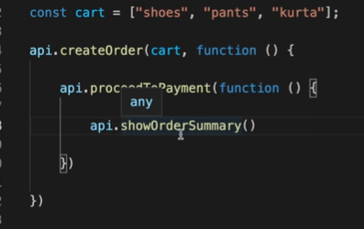

*When multiple asynchronous operations depend on each other, callbacks get deeply nested, making the code hard to read and maintain.
getUser(userId, (user) => {
getOrders(user, (orders) => {
processOrders(orders, (processed) => {
sendEmail(processed, (confirmation) => {
console.log("Order Processed:", confirmation);
});
});
});
});

*Inversion Of control:
-Loose control of function
-This is when you hand over control of your code to a third party (usually a library or a third-party API). This can lead to trust issues and makes error handling difficult.
🔹 The introduction of Promises in JavaScript provided a solution to these problems.
🔹 A Promise is an object that represents the eventual completion or failure of an asynchronous operation. It has three states:
1️⃣ Pending: The Promise's outcome hasn't yet been determined.
2️⃣ Fulfilled: The asynchronous operation has been completed, and the Promise has a resulting value.
3️⃣ Rejected: The asynchronous operation failed, and the Promise will never be fulfilled.
🔹 Once a Promise is fulfilled or rejected, it becomes immutable, meaning its state can't change.
🔹 We use the .then() method to schedule a callback to be run once the Promise is fulfilled or rejected.
🔹 To avoid the Pyramid of Doom, we can chain Promises, allowing our code to expand vertically rather than horizontally. This is done using the .then() method.
🔹 A common mistake developers make is forgetting to return a value during Promise chaining. Always remember to return a value, as this will be used by the next .then() in the chain.

*Promises:
Promise is an object representing the eventual completion or failure of an asynchronous operation . JavaScript Promises make handling asynchronous operations like API calls, file loading, or time delays easier. Think of a Promise as a placeholder/conatiner for a value that will be available in the future.
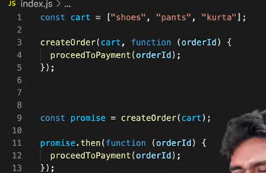
-It can be in one of three states
- Pending: The task is in the initial state.
- Fulfilled: The task was completed successfully, and the result is available.
- Rejected: The task failed, and an error is provided.
-using then() we passed callback function to promise
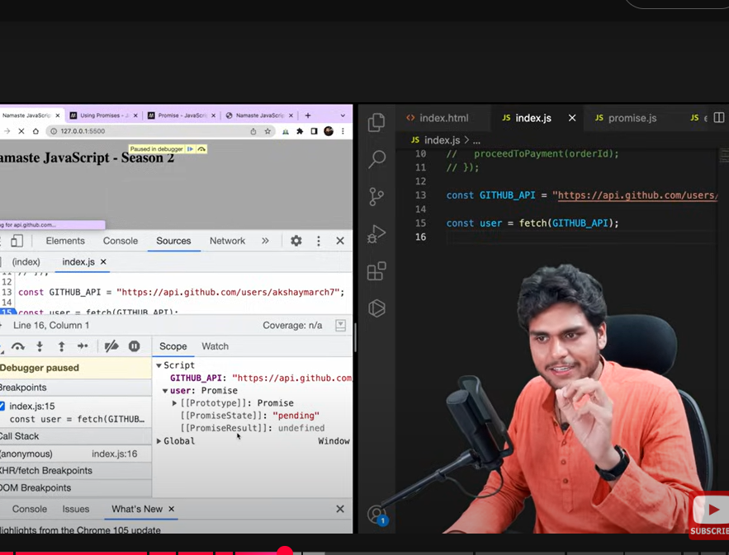
-promise calls only one. We use fetch() to call api: return promise
-PromiseResult: When a Promise object is "fulfilled", the result is a value.
User. then(function(data){
console.log(data) ;
}
Promise Chaining:
createorder(cart).then((orderid)=>proceedToPayment(orderId))
.then((paymentInfo)=> showOrderSummary(PaymentInfo))
.
then((paymentInfo)=>updateWalletBalance(PaymentInfo));

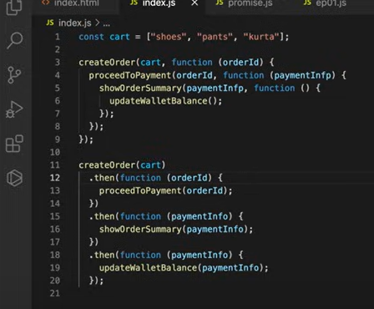

Javascript Notes

